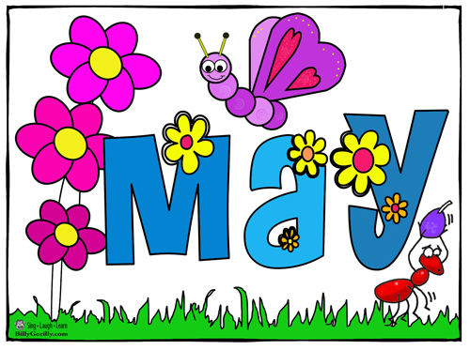
MAY ROSARY
Since May is the “Month of Mary”, we extend an invitation to join us in saying the Rosary at 3:35pm on Saturday and 9:05am on Sunday at 800 Marquette Avenue

WEEKEND SCHEDULE- -800 MARQUETTE AVENUE
Confessions- -3:00pm
Saturday-Mass of Anticipation- -4:00pm
Sunday Masses- -7:30am, 9:30am, 11:00am

FIRST EUCHARIST AND CONFIRMATION- -800 MARQUETTE AVENUE
First Eucharist will be celebrated at the 4pm, 9:30am and 11:00am Masses
on the Weekend of May 6th and 7th
The Sacrament of Confirmation will be celebrated on Sunday, May 7th, at 2pm

EUCHARISTIC ADORATION- -WEDNESDAY’S
8:15am Mass 9:00am Exposition
2:30pm Divine Mercy Chaplet 6:15pm Benediction 6:30pm Mass
Four Saints Chapel at 695 College Avenue

ABIDE
Friday, May 5th - -6pm- -Four Saints Chapel at 695 College Avenue

HEART OF MARY HEALING PRAYER AND ANOINTING OF THE SICK
Wednesday, May 17th- -9am to 9:15am—Four Saints Chapel/695 College Avenue

PRAY AND PLAY
Thursday, May 18th- -9:00am to 10:30am, 800 Marquette Avenue
Contact Annemarie Wood with questions at mrsannemariewood@yahoo.com OR 414-534-5890

CARD CLUB
Monday, May 1st and May 15th- -1:15pm to 4:00pm- -Conference Room at 695 College Avenue, enter via Parish Office

SAYING YES: DISCOVERING AND RESPONDING TO GOD’S WILL IN YOUR LIFE:
Tuesday Evenings from 6:00pm to 7:30pm- -May 2 thru June 6th
800 Marquette Avenue Gathering Space
Cost $15 (the series includes a book)

